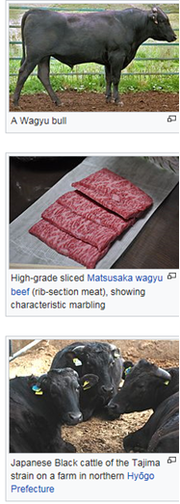 **Wagyu Blockchain Industry Project** (Honours Dept of CS 2018)

BkB in collaboration with Wagyu requires a blockchain project for cattle tracking on the Wagyu farm. Each animal is fitted with a RFID tag. This tag is scanned at various times in the animal’s life, for example when it is 6 months old and inspected by a veterinarian and its body condition, size and general health statistics recorded. In addition, at various stages its food intake, medication and growth are recorded.

You are required to design, develop, implement and evaluate a Blockchain for the lifecycle information of Wagyu cattle in S.A. Keep all information from birth, growth, food intake, medication, RFID tag, etc. on the blockchain. Include locations, movements (to different farming locations), slaughtering, packaging and distribution of the meat. Customers purchasing the meat from a supermarket / butcher must be able to track and verify the meat they are purchasing.